Why do people move from one country to another? [Francesco Castelli](https://watermark.silverchair.com/tay040.pdf?token=AQECAHi208BE49Ooan9kkhW_Ercy7Dm3ZL_9Cf3qfKAc485ysgAAAr0wggK5BgkqhkiG9w0BBwagggKqMIICpgIBADCCAp8GCSqGSIb3DQEHATAeBglghkgBZQMEAS4wEQQM__nO-oFJnvWoft-hAgEQgIICcJEV07PES5f81Wa8cn53amdvOAkB2YH14DXAGaMP00uj9WCLdqiV-xP_yY1e0SK9GylbvHZLGu3dj-5QvADpujPsi5ny_M-fFDU6-Iigxq9rVO2tWMxoLUobsdfGpQs27_FrAzBok-701Syl6F8YEMCaS5QCShH8l9sL9gZAGxxmBB4ScSc-98jjHb8cerLuDpCk72UMK7rNx6n3p-VRJVwxaVUjhvw9_I6VUskk3d2gwtoRltppOlfAk-PcSYdPbFjK70xnBCLX4xdtV1fcZnLVfmDreBZ_Igp-nboYjPDBny7nvUknA-BqF-IoGMPfvSxhHCKvpV2_M41c-kc0FFSaqSsJTznRGGFQTaRm20ZwLwMNJcS4u3VIyV5-j-p1yac5V3s0CrF9HEXGND5FlAdS4vTBQz2F4TvCOttKuWEhYlhRj26C-5FkvLGaPVV5tv5hFqfc_Z-bKT4-t0UmcussnZdhW2U7KqF7aewiKkDCWY-a13MUVIc6DeYpYpI96eRJmTEs2HZTd-mg0-qf7dcIHEBOk8FiuZnP3gyrX1YDVXfgdhvl0LfIW5bkEi3Y9RjWfRdSXmcCinY8qQWsrOc7ZdICxJPbMbIw2eJollb34V8XY-vd2XRfzkDRG7T7kq0_XtTzB0X4dJoiSOWiKBD4mIuykrnFTvU-8cqHPOTbg6OLTkQ-mV2JDVE9J1hgD1A4pOPxd-nGgAjuw7RPn5CWOw-w8mjH_bEgihlKpkg_H5EIx0wtAmHSGsTqCk6EXLYbHlBakXBcMaLvVQXBJVivgxuTEgLCQsXBuKxOnSZPXu1SUpF6EqNVXI0LOh2XCQ), UNESCO Chair ‘Training and Empowering Human Resources for Health Development in Resource-Limited Countries’ gives the following as drivers of migration:

* Inadequate human and economic development
* Demographic increase, urbanization
* Climate changes
* Wars and dictatorship
* Land grabbing
* Religion
* Sexual identity
* Personal willingness to migrate

Immigration into the US is an important issue for me personally. I am the child of immigrant parents who were born in Poland. I was born in Italy and became a naturalized citizen once my parents became naturalized citizens of the US. I have always admired the work ethic of immigrants. As a group, immigrants have realized the hardship of their home country (the lack of employment, the lack of religious freedom, the lack of opportunity) and the desire to improve their situations in another location. These constraints (the lack of the command of English, limited education, limited employment opportunities), rather than impeding success in the US, many times serve as drivers for immigrants to succeed in the US.

DATA ANALSIS & MANIPULATION

For the final project, the class was asked to select a topic of interest from Census data. I chose data from 2021 relating to Immigration (5-year) – lists fields of relevance to capturing information on naturalized Citizens and non-Citizens in the US (by State)

|  |  |  |  |
| --- | --- | --- | --- |
| **Data Columns** | **Current Status 2021** | **Entered US 2010+** | **Entered US 2000-2010** |
| State of residence |  |  |  |
| Region of origin |  |  |  |
| Immigration Status |  |  |  |
| Sex |  |  |  |
| Age |  |  |  |
| Marital status |  |  |  |
| Education |  |  |  |
| Employment: In labor force/not in labor force |  |  |  |
| Income |  |  |  |
|  |  |  |  |

Census Data By State

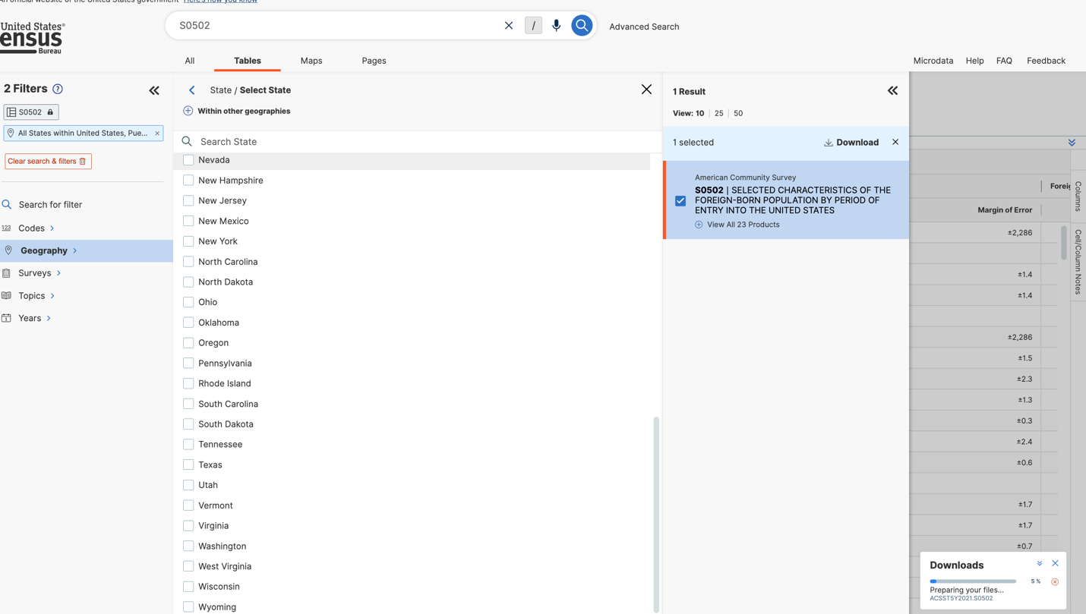

Data

ACSST5Y2021.S0502-Table-Notes.txt

ACSST5Y2021.S0502-Column-Metadata.csv – data dictionary showing each column heading and description

ACS Report by State.xlsx- Data represented as a report from ACS

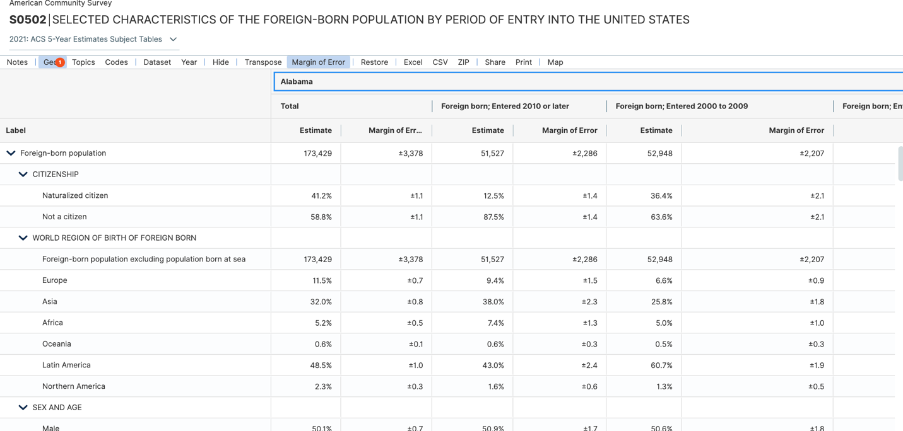

ACSST5Y2021.S0502-Data.csv– data as a csv file; data is grouped by state; not able to pull data for all US as one row csv file (yet the report from ACS can be generated this way)

Table has 2,239 columns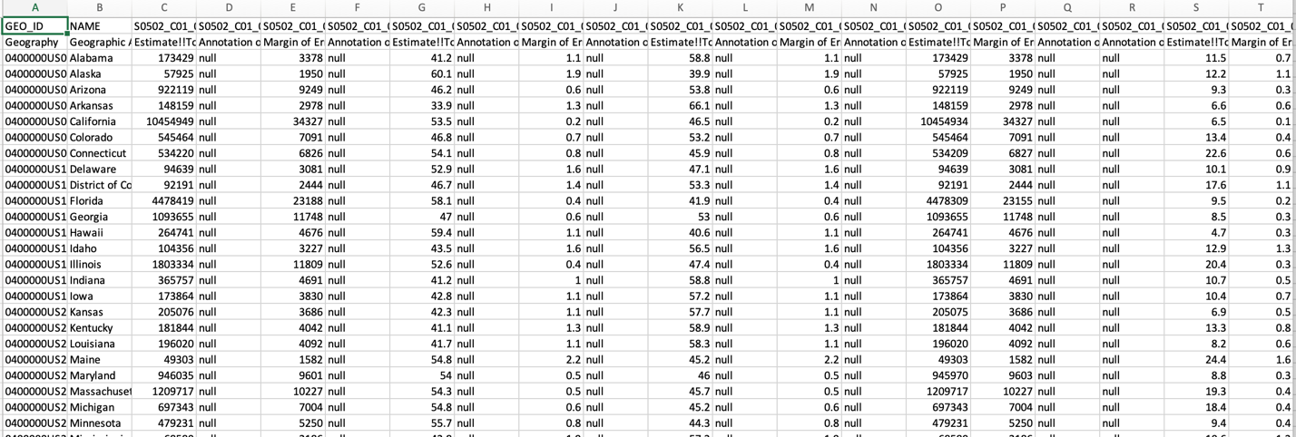

Uniqueness of S0502 data:

* GEO_ID & NAME are unique
* 584 columns of data, of which only 438 columns for each grouping begin with S0502_C01_, S0502_C02, S0502_C03, S0502_C04

INITIAL PLANS

My initial plan: compare changes across span of when Immigrant came to US (using the Data Column fields above)

File layout: 345 columns; beginning with GEOID and State, the remaining fields where duplicated 4 times (corresponding to year being tracked (Totals [which is the equivalent of 2021], Entered 2010+, Entered 2000-2009, Entered before 2000)

Download as a report grouped by State

Report avail as a csv file

Structure of csv file

Manipulating the file to get it into a format I could report on using d3

Initial file appears as one row for each state with 2,338 columns

MANIPULATION

1. Delete row for Puerto Rico
2. Delete all column headings (after GEOID and NAME) that do not begin with S0502_CO1_
3. Delete all column headings that do not end in E

*This will leave you with all the values that are not estimates (which is the equivalent of 2021 data)*

1. (Equivalent of Deleting all columns that have null in all rows)

*:*

Problems with the file once downloaded using d3: Numeric fields appear as string

Adding “+” to field in code converts it to a numeric

INITIAL SKETCH

Structure of process:

* Bar Graph with States on x-Axis and Numeric fields (Population, etc.) on y-Axis

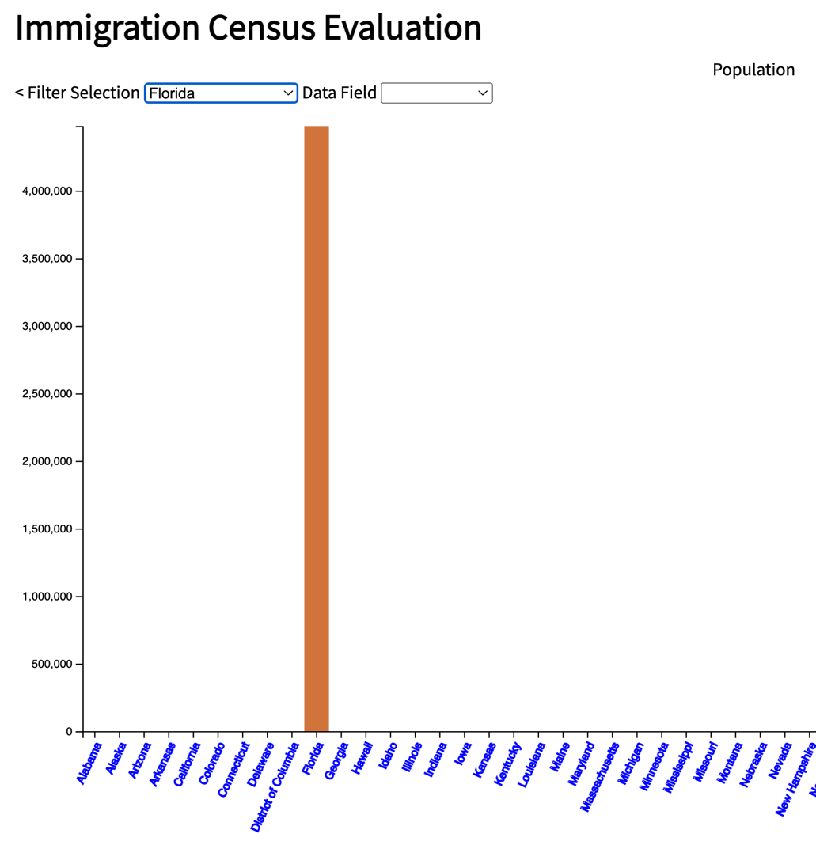

Selection criteria:

select by State (passed from drop-down list)

select by Data Column (passed from drop-down list)

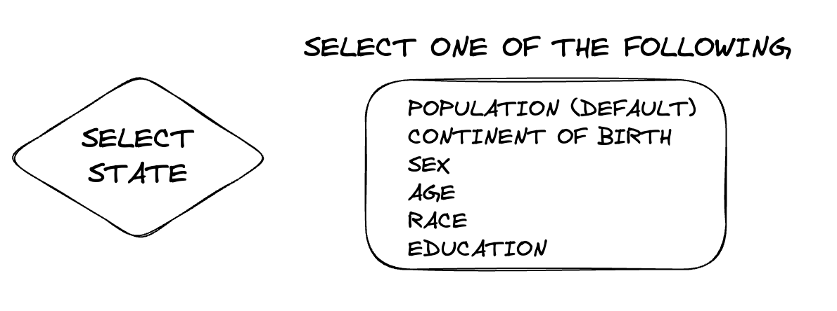

Idea is to have data column name passed as field required by yScale

ISSUES

Issue identifying numeric field (i.e., population) when value is passed to yScale domain.

Resolved – 5/15/2023: yScale domain is expecting an array with 2 elements;

REFLECTIONS

I haven’t developed a website since DREAMWEAVER MX 2004 which Macromedia released in 2004 (product has since been bought by Adobe and integrated in its CS package). I still maintain an MX 2004 website that I built for my wife’s business.

Shortcomings:

* I needed to relearn HTML and CSS since I had been using 15-year-old version.
* Since most of my classmates and instructor were using a Mac, I decided to get a Mac after the first class. This presenting another learning curve I had to overcome, as I had only worked on a PC before. (As the Mac keyboard shortcuts are different from the PC, and interoperable workings between programs on the Mac were different that the PC, I felt it was important that I use the Mac to write the code, so I could test the results the same way as the instructor.)
* I also had limited experience with JavaScript which I tried to make up by reading a JavaScript textbook. This lack of knowledge impacted on my ability to grasp what was being taught in the Data Visualization course. The process got better as my experience with understanding how HTML and CSS has changed. Learning the basics of DOM was another challenge. I was able to get help from other classmates who had learned these basic concepts. However, it also meant that I couldn’t completely follow the instructor’s presentation of coding examples. This improved slowly over time. The best solution was having the instructor record the lesson as a Zoom session so I could replay it after the class and write and test the code she was presenting.
* My experience with visualizations of data was limited to the creation of Charts in Excel, based on PivotTable data. These charts are static; and once I saw chart productions that displayed changes dynamically over time, my heart was set on the need to master this skill. Visualizations, that change dynamically with the data, help people understand clearly what has happened over time ... and can get one to focus on what factors drove this change.

THINGS TO DO

* Find and fix the issue with the data so that numeric data is passed to yScale - done 5/15/2023
* Fix issue with all state populations not appearing on bar chart when no state is selected (setting this as a default
* Fix color legend so that colors other than ORANGE are used (when different states are selected)
* Expand the project to compare data over the 3 timespans (current, 2010+, 2000-2009).
* Develop charts as Scatter and Circle (to see if they display the data in a more insightful manner